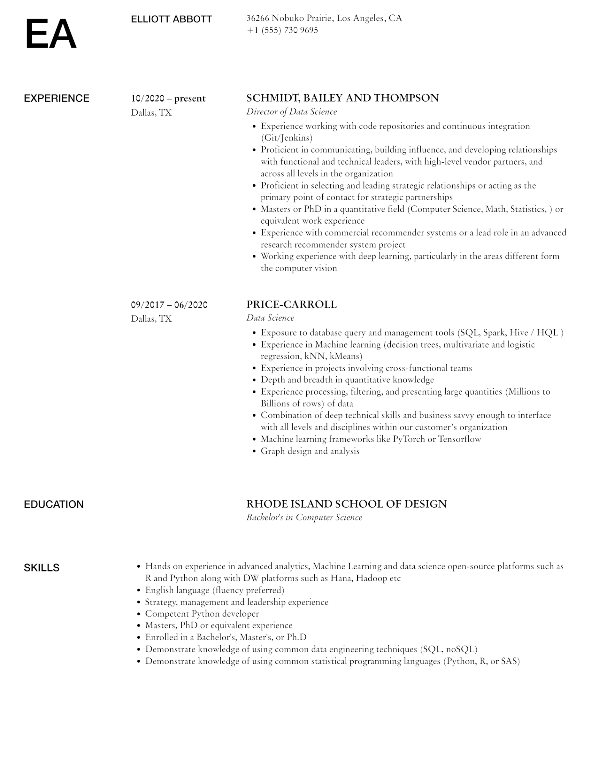
EA
ELLIOTT ABBOTT
36266 Nobuko Prairie, Los Angeles, CA
+1 (555) 730 9695
EXPERIENCE
10/2020-present Dallas, TX
EDUCATION
SKILLS
09/2017 - 06/2020 Dallas, TX
SCHMIDT, BAILEY AND THOMPSON
Director of Data Science
·
· Experience working with code repositories and continuous integration (Git/Jenkins)
• Proficient in communicating, building influence, and developing relationships with functional and technical leaders, with high-level vendor partners, and across all levels in the organization
• Proficient in selecting and leading strategic relationships or acting as the primary point of contact for strategic partnerships
• Masters or PhD in a quantitative field (Computer Science, Math, Statistics,) or equivalent work experience
·
•
Experience with commercial recommender systems or a lead role in an advanced research recommender system project
Working experience with deep learning, particularly in the areas different form the computer vision
PRICE-CARROLL
Data Science
•
•
·
•
·
Exposure to database query and management tools (SQL, Spark, Hive / HQL)
Experience in Machine learning (decision trees, multivariate and logistic regression, kNN, kMeans)
Experience in projects involving cross-functional teams
Depth and breadth in quantitative knowledge
Experience processing, filtering, and presenting large quantities (Millions to Billions of rows) of data
• Combination of deep technical skills and business savvy enough to interface
with all levels and disciplines within our customer's organization
• Machine learning frameworks like PyTorch or Tensorflow
·
Graph design and analysis
RHODE ISLAND SCHOOL OF DESIGN Bachelor's in Computer Science
• Hands on experience in advanced analytics, Machine Learning and data science open-source platforms such as R and Python along with DW platforms such as Hana, Hadoop etc
Strategy, management and leadership experience
•
English language (fluency preferred)
•
Competent Python developer
•
Masters, PhD or equivalent experience
·
Enrolled in a Bachelor's, Master's, or Ph.D
• Demonstrate knowledge of using common data engineering techniques (SQL, noSQL)
• Demonstrate knowledge of using common statistical programming languages (Python, R, or SAS)

